**Project 1.C**

1. Project Description

Figure 1 shows an ER diagram for University database. This is the same in Project 1.A and 1.B.

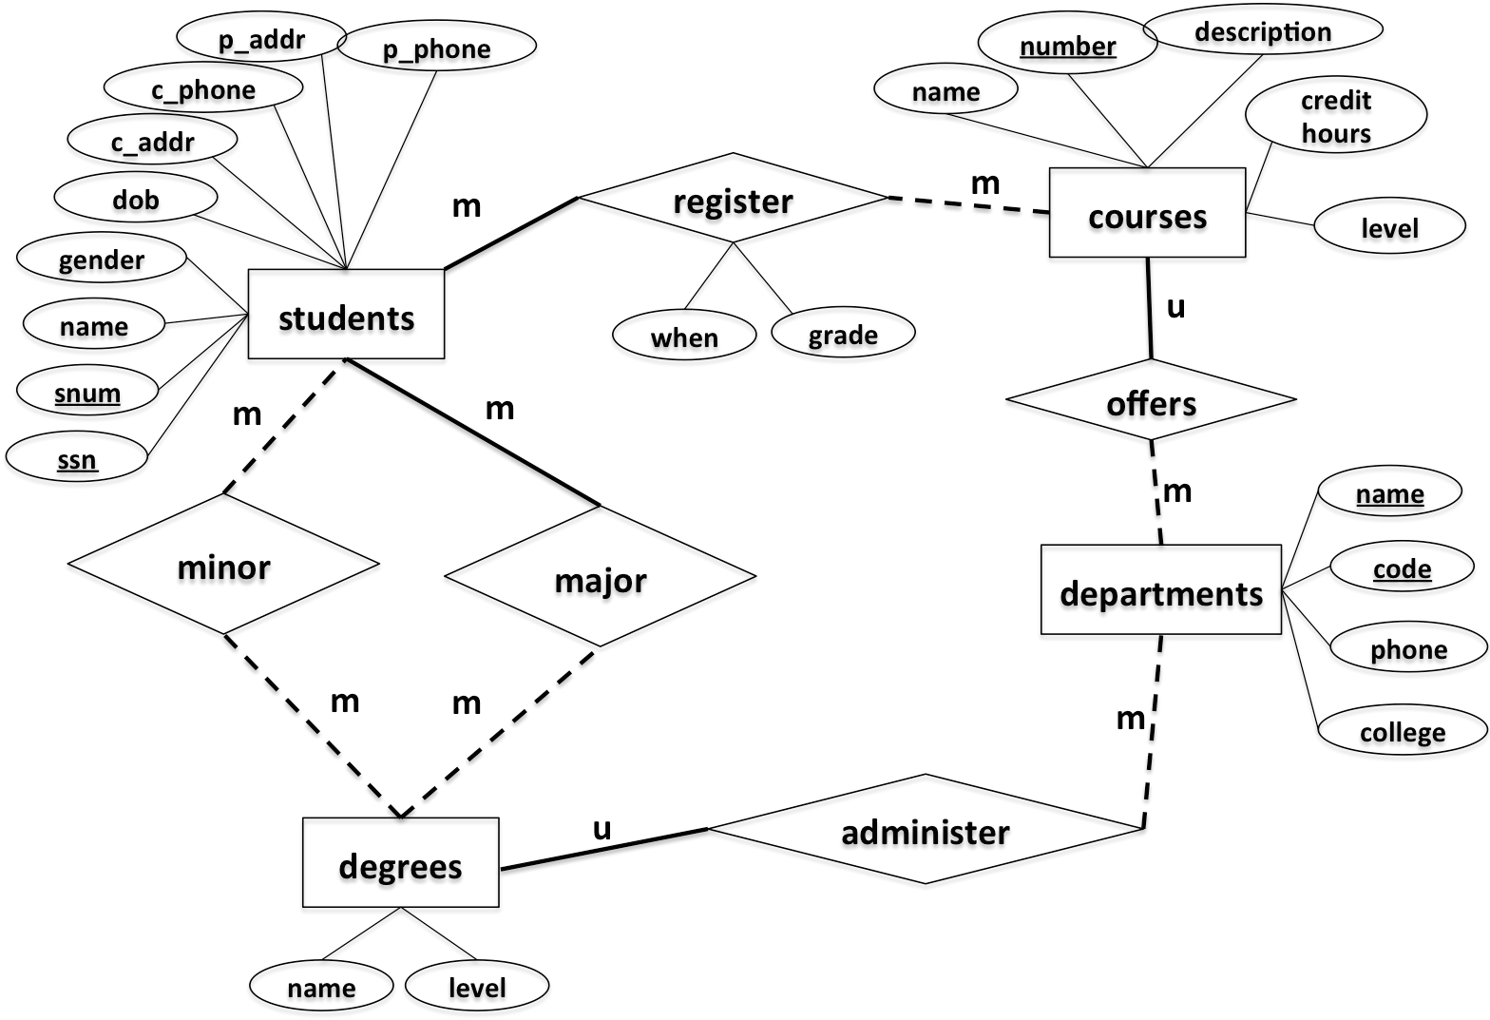

Figure 1. ER-diagram

This project is to implement the above design using a relational data model. Specifically, you are asked to write the following JavaServer Pages (JSP).

1. **CreateTables.jsp and CreateTablesResult.jsp [Points: 15]**

*CreateTables.jsp*

This web page has one submit button (See Figure below). When clicking the button, it creates the following tables and redirect to CreateTablesResult.jsp. Those seven tables are:

* students
  1. Attribute, type and length: *snum: integer, ssn: integer, name: varchar(10), gender: varchar(1), dob: datetime, c_addr: varchar(20), c_phone: varchar(10), p_addr: varchar(20), p_phone: varchar(10)*
  2. Primary key: *snum*
  3. Candidate key: *ssn*
  4. Foreign key: *N/A*
* departments
  1. Attribute, type and length: *code: integer, name: varchar(50), phone: varchar(10), college: varchar(20)*
  2. Primary key: *code*
  3. Candidate key: *name*
  4. Foreign key: *N/A*
* degrees
  1. Attribute, type and length: *name: varchar(50), level: varchar(5),* department_code: integer
  2. Primary key: *name, level*
  3. Candidate key: *N/A*
  4. Foreign key: *department_code refers to code in table departments*
* courses

1. Attribute, type and length: *number: integer, name: varchar(50), description: varchar(50), credithours: integer, level: varchar(20), department_code: integer*
2. Primary key: *number*
3. Candidate key: *name*
4. Foreign key: *department_code refers to code in table departments*

* register

1. Attribute, type and length: *snum: integer, course_number: integer, when: varchar(20), grade: integer*
2. Primary key: *snum, course_number*
3. Candidate key: *N/A*
4. Foreign key: *snum refers to snum in table students, course_number refers to number in table courses*

* major

1. Attribute, type and length: *snum: integer, name: varchar(50), level: varchar(5)*
2. Primary key: *snum, name, level*
3. Candidate key: *N/A*
4. Foreign key: *snum refers to snum in table students, name & level refer to name & level in table degrees*

* minor

1. Attribute, type and length: *snum: integer, name: varchar(50), level: varchar(5)*
2. Primary key: *snum, name, level*
3. Candidate key: *N/A*
4. Foreign key: *snum refers to snum in table students, name & level refer to name & level in table degrees*

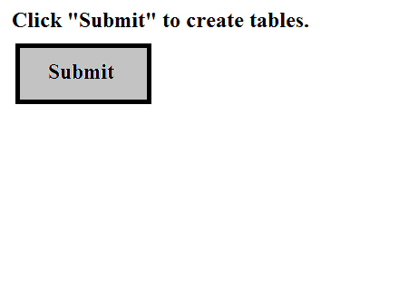

Figure 2: Example of CreateTables.jsp

*CreateTablesResult.jsp*

This page will display a result of tables creation (See Figure below).

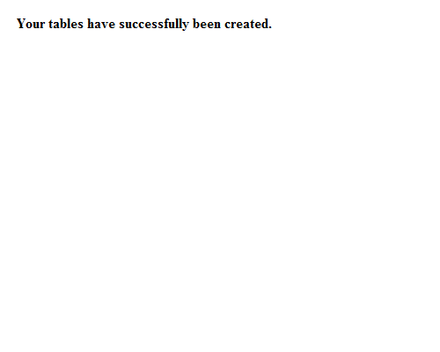

Figure 3: Example of CreateTablesResult.jsp

1. **InsertRecords.jsp and InsertRecordsResult.jsp [Points: 15]**

*InsertRecords.jsp*

A web page has one submit button (See Figure below). When clicking the button, your web page must insert data records based on entered SQL syntax. Finally, it will redirect the user to InsertRecordsResult.jsp. Those data records are:

* **students**

|  |  |  |  |  |  |  |  |  |
| --- | --- | --- | --- | --- | --- | --- | --- | --- |
| snum | ssn | name | gender | dob | c_addr | c_phone | p_addr | p_phone |
| 1001 | 654651234 | Randy | M | 2000/12/01 | 301 E Hall | 5152700988 | 121 Main | 7083066321 |
| 1002 | 123097834 | Victor | M | 2000/05/06 | 270 W Hall | 5151234578 | 702 Walnut | 7080366333 |
| 1003 | 978012431 | John | M | 1999/07/08 | 201 W Hall | 5154132805 | 888 University | 5152012011 |
| 1004 | 746897816 | Seth | M | 1998/12/30 | 199 N Hall | 5158891504 | 21 Green | 5154132907 |
| 1005 | 186032894 | Nicole | F | 2001/04/01 | 178 S Hall | 5158891155 | 13 Gray | 5157162071 |
| 1006 | 534218752 | Becky | F | 2001/05/16 | 12 N Hall | 5157083698 | 189 Clark | 2034367632 |
| 1007 | 432609519 | Kevin | M | 2000/08/12 | 75 E Hall | 5157082497 | 89 National | 7182340772 |

* **departments**

|  |  |  |  |
| --- | --- | --- | --- |
| **code** | **name** | **phone** | **college** |
| 401 | Computer Science | 5152982801 | LAS |
| 402 | Mathematics | 5152982802 | LAS |
| 403 | Chemical Engineering | 5152982803 | Engineering |
| 404 | Landscape Architect | 5152982804 | Design |

* **degrees**

|  |  |  |
| --- | --- | --- |
| **name** | **level** | **department_code** |
| Computer Science | BS | 401 |
| Software Engineering | BS | 401 |
| Computer Science | MS | 401 |
| Computer Science | PhD | 401 |
| Applied Mathematics | MS | 402 |
| Chemical Engineering | BS | 403 |
| Landscape Architect | BS | 404 |

* **major**

|  |  |  |
| --- | --- | --- |
| **snum** | **name** | **level** |
| 1001 | Computer Science | BS |
| 1002 | Software Engineering | BS |
| 1003 | Chemical Engineering | BS |
| 1004 | Landscape Architect | BS |
| 1005 | Computer Science | MS |
| 1006 | Applied Mathematics | MS |
| 1007 | Computer Science | PhD |

* **minor**

|  |  |  |
| --- | --- | --- |
| **snum** | **name** | **level** |
| 1007 | Applied Mathematics | MS |
| 1005 | Applied Mathematics | MS |
| 1001 | Software Engineering | BS |

* **courses**

|  |  |  |  |  |  |
| --- | --- | --- | --- | --- | --- |
| **number** | **name** | **description** | **credithours** | **level** | **department_code** |
| 113 | Spreedsheet | Microsoft Excel and Access | 3 | Undergraduate | 401 |
| 311 | Algorithm | Design and Analysis | 3 | Undergraduate | 401 |
| 531 | Theory of Computation | Theorem and Probability | 3 | Graduate | 401 |
| 363 | Database | Design Principle | 3 | Undergraduate | 401 |
| 412 | Water Management | Water Management | 3 | Undergraduate | 404 |
| 228 | Special Topics | Interesting Topics about CE | 3 | Undergraduate | 403 |
| 101 | Calculus | Limit and Derivative | 4 | Undergraduate | 402 |

* **register**

|  |  |  |  |
| --- | --- | --- | --- |
| **snum** | **course_number** | **when** | **grade** |
| 1001 | 363 | Fall2015 | 3 |
| 1002 | 311 | Fall2015 | 4 |
| 1003 | 228 | Fall2015 | 4 |
| 1004 | 363 | Spring2015 | 3 |
| 1005 | 531 | Sprng2015 | 4 |
| 1006 | 363 | Fall2015 | 3 |
| 1007 | 531 | Spring2015 | 4 |

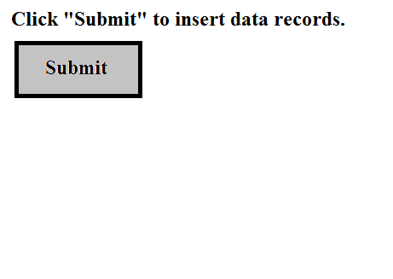

Figure 4: Example of InsertRecords.jsp

*InsertRecordsResult.jsp*

This page will display a result of records insertion (See Figure below).

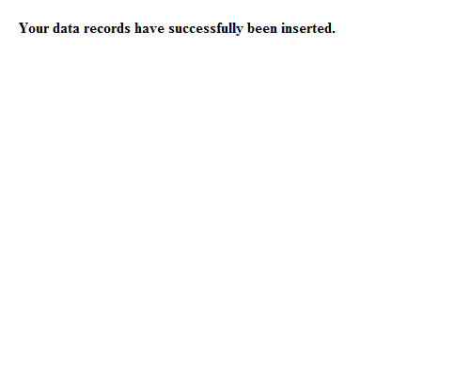

Figure 5: Example of InsertRecordsResult.jsp

1. **Query.jsp, QueryResult1.jsp, QueryResult2.jsp, QueryResult3.jsp [Points: 55]**

*Query.jsp*

A web page has **THREE** buttons (See Figure below). When clicking any button, your web page must query data records based on corresponding query. Finally, it will redirect the user to either QueryResult1.jsp or QueryResult2.jsp or QueryResult3.jsp based on corresponding query to show query results. Those three queries are:

* 1. The student number and ssn of the student whose name is "Becky"
  2. All degree names and levels offered by the department of Computer Science
  3. The course numbers and names of all courses offered by either Department of Computer Science or Department of Landscape Architect.

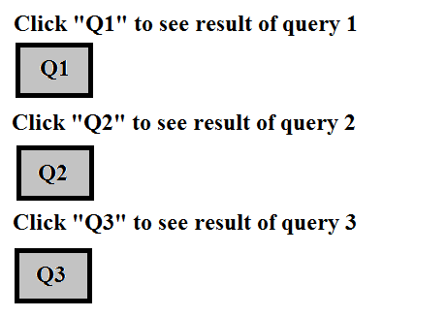

Figure 6: Example of Query.jsp

*QueryResult1.jsp, QueryResult2.jsp, QueryResult3.jsp*

This page will display a result of corresponding query (See Figure below).

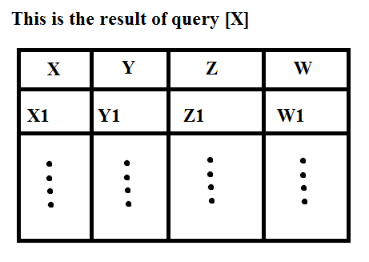

Figure 7: Example of QueryResultX.jsp

1. **ModifyRecords.jsp and ModifyRecordsResult.jsp [10]**

*ModifyRecords.jsp*

A web page has one submit button (See Figure below). When clicking, your web page must modify a data record. Finally, it will redirect the user to ModifyRecordsResult.jsp. This is a modification:

1. Change the name of the student with ssn = 746897816 to Scott

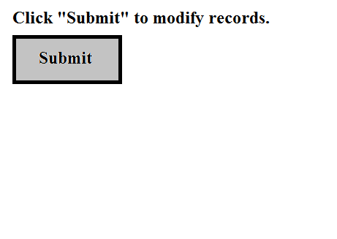

Figure 8: Example of ModifyRecords.jsp

*ModifyRecordsResult.jsp*

This page will display a result of record modification (See Figure below).

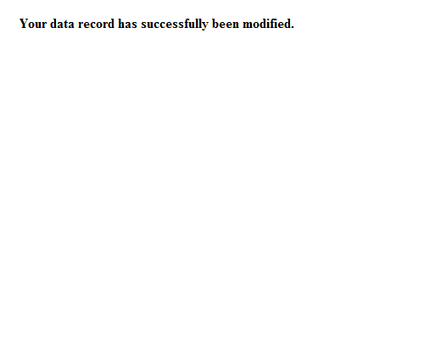

Figure 9: Example of ModifyRecordsResult.jsp

**Submission Instruction**

***U****pload all JSP files (CreateTables.jsp, CreateTablesResult.jsp, InsertRecords.jsp, InsertRecordsResult.jsp, Query.jsp, QueryResult1.jsp, QueryResult2.jsp, QueryResult3.jsp, ModifyRecords.jsp, and ModifyRecordsResult.jsp) to your account in Canvas.*

1. Set up a local working environment using Eclipse

SSG is supposed to set up a working environment for us. However, they are not helping anything yet. So let’s set up a local working environment. Specifically, you follow these steps.

* 1. Make sure that you have Java JDK installed in your computer, if not, you can get Java JDK at <http://www.oracle.com/technetwork/java/javase/downloads/index.html>
  2. Download and install Eclipse IDE at <https://eclipse.org/downloads/> (choose “Eclipse IDE for Java EE Developers”)
  3. Download and install Connector J at <https://dev.mysql.com/downloads/connector/j/>
  4. Download Tomcat Server (Zipped file) at <http://tomcat.apache.org/download-80.cgi> and unzip it to your preferred directory.

1. Set up Tomcat Server and Create Dynamic Web Project in Eclipse
   1. Create new Server in Eclipse by go to “New > Server > Server”, then, click “Next”.

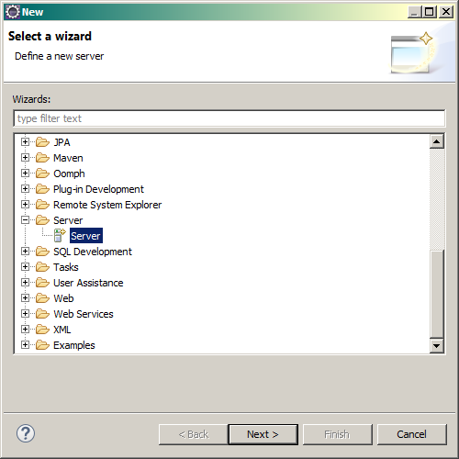

* 1. Select “Tomcat v8.0 Server”, then, click “Next”.

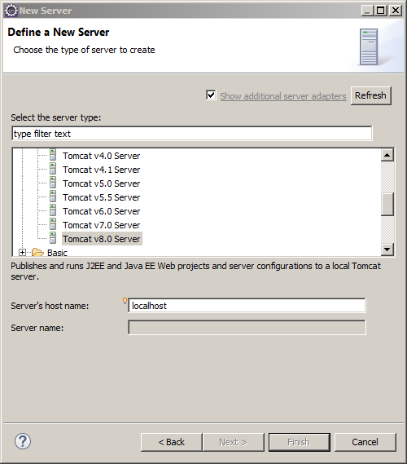

* 1. Click “Browse…”, then, select the directory that you unzipped Apache Tomcat Server. Click “Finish”.

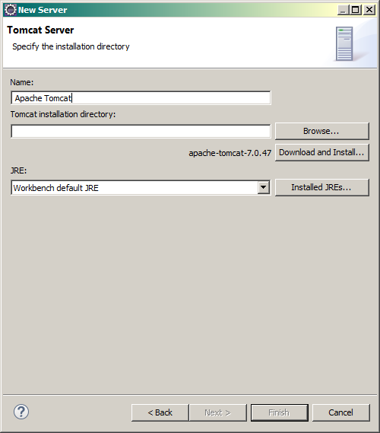

* 1. Create new Dynamic Web Project by go to “File > New > Other”, then select Dynamic Web Project under “Web” folder.

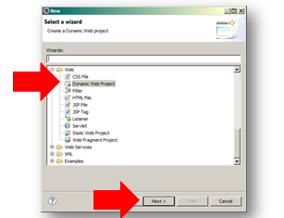

* 1. Specify Project name and Target runtime (Tomcat server that installed in your Eclipse at step 3). Click “Finish”.

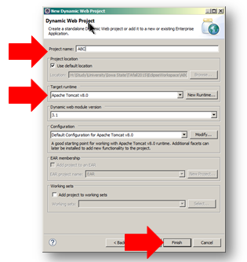

* 1. You will get the Project Explorer like this:

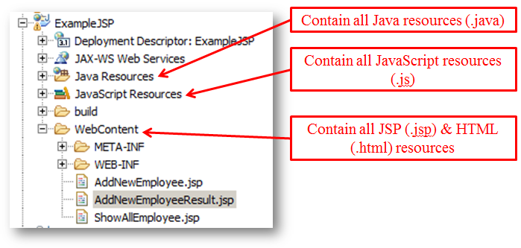

* 1. Add Connector J JAR file to your build path by right-click at your project and select “Build Path > Configure Build Path”.
  2. Select Libraries tab and click “Add External JARs”.

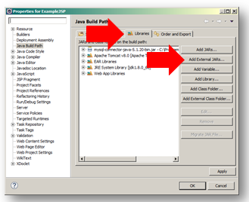

* 1. Go to the directory that you stored Connector J JAR file and select it. Then click “OK”.
  2. Next, go to that directory again and **COPY** your Connector J JAR file manually.

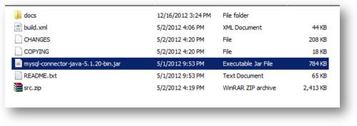

* 1. Go to “[Your Project Folder]\WebContent\WEB-INF\lib\” and paste Connector J JAR file to that folder.

1. Example of JSP Codes

In order to create JSP page, follow these steps:

* 1. Right-click at WebContent folder (in Project Explorer) and select “WebContent > New > JSP File”.
  2. Specify the name of your new JSP file and click “Finish”.

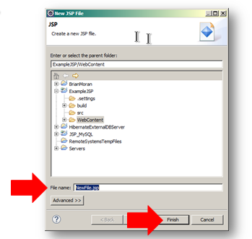

* 1. Next, in order to connect to database, you need to have these statements in your JSP code:
     + To import necessary libraries:

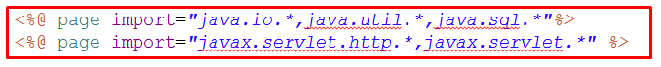

* + - To establish a JDBC connection:

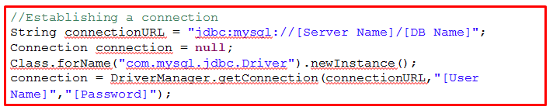

* To select data from database:

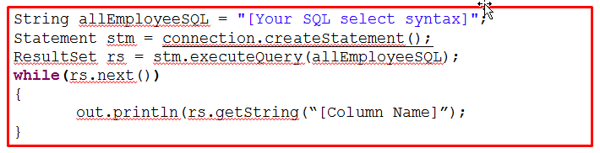

* To insert/update/delete data:

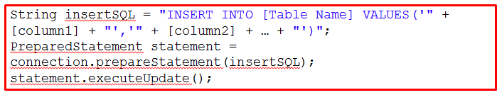

* To get value from HTML form

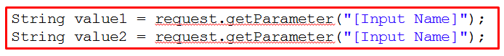

* 1. Please note that JSP page consists of both HTML code and Java code. Every time you write any Java code inside JSP page, you have to wrap all your Java codes inside the scripting delimiter:

<% --- Your Java Code ---%>

1. Tutorial
   1. This page shows you how to create and run simple JSP application in Eclipse: <http://www.srccodes.com/p/article/2/JSP-Hello-World-Program-using-Eclipse-IDE-and-Tomcat-web-server>
   2. This page shows you how to use “Form” to retrieve values from any control (textbox, check box, etc.) and send those values to another JSP page: <http://www.tutorialspoint.com/jsp/jsp_form_processing.htm>